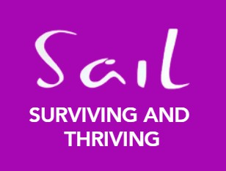June 2024

NEWS

OUR YEAR SO FAR…

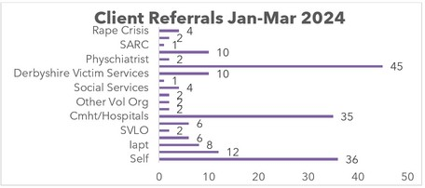

# CLIENT FEEDBACK

 REFERRALS

## It’s been quite a busy few months at SAIL

We have seen a 50% increase in referrals compared to last year.

**Counselling – Jan-Mar 105** clients on average are receiving counselling each month. At the end of December, we had 309 clients on the waiting list. An increase in clients in the last quarter of 24%.

**Helpline – Jan-Mar** There were 733 contacts made via call, texts & emails. That is an increase of 58% on the last quarter!

**Referrals –Jan-Mar** We have had 190 clients seeking counselling. This is an increase of 32%.

**Isva – Jan-Mar** have seen an increase and have supported 71 clients, an increase of 13% on the last quarter.

## What did you appreciate about SAIL

‘I found the initial meeting friendly and welcoming.’

‘It went well, counsellor was empathetic and really listened to what I had to say.’

‘For the first time in 33years I had people I could talk to, who genuinely cared and wanted to help me.’

‘Sail and ISVA team helped me to get PIP and have supported me with my bills and housing needs.’

‘Very caring and considerate, warm feeling from start to finish.’ ‘My therapist is the best therapist I have ever had.’

‘I found a community of people who would understand me, not judgmental. I know I am not alone.’

‘The room was welcoming and inviting, safe space to talk.’

# OUTCOMES

## “Trust And Hope”

Among the clients who concluded their counselling sessions during this period, an impressive 76% reported that they departed from our service with a heightened sense of trust and an increased feeling of hope. This significant outcome highlights the effectiveness of our counselling approach in fostering a positive mindset and underscores our commitment to supporting our clients in building a more optimistic outlook for their future.

In our concerted efforts to enhaEnce theVvisibiliEty and NpromoteTunderSstanding of our services within the local

community, SAIL has proactively participated in a myriad of network meetings and outreach events spanning across the entirety of the county. Perhaps you've had the chance to encounter us at the recent ThinkFest!, an esteemed event held in May. ThinkFest! stands as Derbyshire's pioneering mental health style festival, a significant platform fostering open dialogues and heightened awareness concerning mental health, suicide prevention, and overall wellbeing, strategically situated in the heart of Chesterfield town centre.

# PLACEMENT PROVIDER DAY

## Elisabeth and Lisa

Elisabeth and Lisa participated in Placement Provider Day at the Sherwood Institute to actively promote Sail. Their objective was to attract potential placement volunteers who could contribute to expanding the counselling services available to our clients. This event provided an excellent opportunity to network and showcase the benefits and significance of our counselling program. By engaging with attendees and sharing our mission, Elisabeth and Lisa aimed to highlight the positive impact that additional volunteers could have on our ability to support and assist more individuals in need. Their efforts were focused on recruiting passionate and committed volunteers who are eager to make a difference in the lives of our clients through dedicated counselling services.

# DERBY UNIVERSITY FRESHERS

## Karen and James

4o

On the 15th of February, Karen and James attended a refreshers event at Derby University with the primary objective of spreading awareness about our services. This event provided them with a valuable opportunity to engage directly with both students and staff members, offering detailed information about the various forms of assistance and support we provide. They set up an informative booth and distributed promotional materials, including brochures and flyers, which highlighted our key services and their benefits. Through interactive discussions and Q&A sessions, they were able to address specific queries and concerns, ensuring that attendees left with a comprehensive understanding of how our services can aid them in their academic and personal lives. This initiative was part of our ongoing efforts to strengthen our presence within the university community and to reinforce our commitment to supporting the well-being and success of all its members.

# MEDIA

## Take a look

Also as part of Sexual Violence Awareness week Sail created and shared some videos and collaborated with The Willow Pod to create a Podcast please click the links below to watch 😊

Podcast with The Willow Pod

<https://audioboom.com/posts/8449866-we-speak-to-reena-and-anita-from-sail>

A video from our Volunteer Coordinator Elisabeth on Group Therapy <https://x.com/SAILCounselling/status/1755154434584363440>

Our male support worker James provided a video for Male Survivors <https://x.com/SAILCounselling/status/1754799593554923769>

A walk-through video of our Chesterfield premises as a ‘client’: <https://x.com/SAILCounselling/status/1754437207409279384>